Rural Development Opportunity Fund

Auction 904 Long-Form Stage II Detailed Technical Submission

Date:
Applicant:
FRN:
State(s):
Performance Tier(s):

GENERAL GUIDANCE:
- The use of this template is optional and voluntary.
- This template does not supersede or modify any of the orders, public notices, rules, or policies that have been or will be adopted by the Commission for the Rural Digital Opportunity Fund and Auction 904. See the Commission’s Auction 904 website for more information, including a tutorial regarding the Stage II detailed technical submission: https://www.fcc.gov/auction/904.
- The long-form is meant to be detailed in nature and approaches an LLD (Low Level Design).
- This is a document submitted from one engineer to another engineer.
- We encourage the use of technically valid TERMINOLOGY.
- We encourage the use of precision language for technical terms.
  - Do not say priority or QoS; Use terms such as: DSCP, Diff Serv, TOS, etc.
  - Do not say routing protocols; Use terms such as: OSPF, IS-IS, EIGRP, BGP, etc.
  - Do not say traffic engineering; Use terms such as: MPLS, VPLS, VLANs, etc.
- This is a forward-looking – future-oriented document for the 10-year span of this program.
- Our questions are asking for the minimum. You can add more.
- Each question must be answered completely. There will be portions of your answers that may be repetitious and may have been used as part of an answer to other questions. This is expected. Answer each question completely where it is asked.
- The spacing between questions below DOES NOT INDICATE THE DESIRED LENGTH OF YOUR ANSWER. Indeed, the blank lines merely represent a placeholder. LONGER ANSWERS ARE EXPECTED.
- If an answer encompasses multiple technologies – please use separate paragraphs in your answers below to differentiate between how separate technologies or network designs are to be implemented. For example, one paragraph for fiber, a second for Cable and a third for fixed wireless when answering question 1a) for last-mile. Separate paragraphs could also be done if there are variations in the network due to differences such as state(s) in question 1c).
- Please add equipment and software vendor names for most answers that use equipment and software. Not every minor vendor name but the major or significant vendors.
- Overall Network Design. A long-form applicant, regardless of the technology (or technologies) it proposes to use, is expected to:

  - Describe the proposed last mile architecture(s), design, and technologies.

  - Describe the proposed middle mile/backhaul topology, architecture, design, and technologies.

  - Describe the proposed interconnection architecture, design, and technologies solution to connect to the Internet. This will include the likely service providers, link data-rate/size, locations, dual-homing, and multi-homing characteristics.

  - Describe the proposed architecture that will be used to provide voice service. Describe whether the proposed voice services will: 1) be internally provided, 2) use a managed voice service provider, 3) use a voice over the top service, or 4) use another type of voice service.

  - Describe the network’s scalability to support customer growth and network data usage growth to account for: 1) ever increasing application requirements, 2) increasing quality demands, and 3) lower response/latency demands for ever increasing usage of highly interactive applications.

  - Describe the design and features that it proposes to implement that will: improve reliability (such as redundancy) for equipment, links and software; dual homing; and multi-homing connectivity.

  - Describe network infrastructure ownership. Indicate which parts of the network will use the long-form applicant’s or another party’s existing network facilities, including both non-wireless and wireless facilities extending from the network to customers’ locations. For non-wireless facilities that do not yet exist, the description should indicate whether the new facilities will be aerial, buried, or underground. This includes leased lines, transit services, rented tower space for radios, etc.

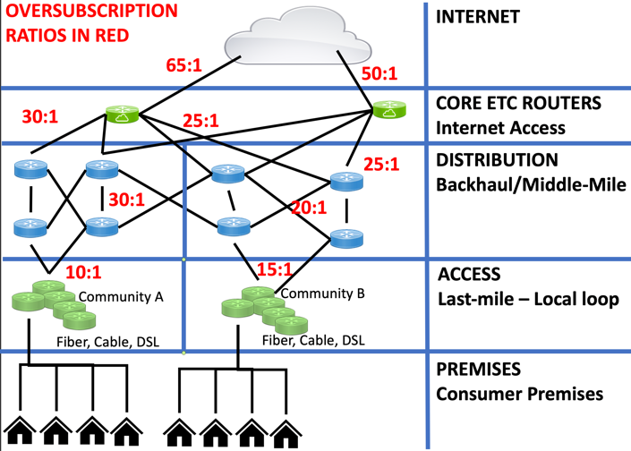
  - Provide technical information about the design methods, “rules of thumb,” and engineering assumptions used to size the capacity of the network’s nodes (or gateways), links and wireless base stations. These are often expressed as ratios, such as “oversubscription ratio” applied in the middle-mile/backhaul and interconnection network levels that funnel the consumer traffic to the Internet. The information provided should demonstrate how the required performance for the relevant performance tier will be achieved during periods of peak usage, downstream and upstream speed, and latency assuming a 70% subscription rate by the final service milestone. For example, the diagram below shows the various oversubscription ratios, link media (wired, wireless, etc.), redundancy and multi-homing in a visual format. It can also be described in text with no need for a diagram. Regardless, we do expect sufficient technical detail rather than a simplistic approach. We expect several ratios as shown and not a simple statement that the network “will use a 20:1 ratio” since ratios are generally different at different levels and locations.

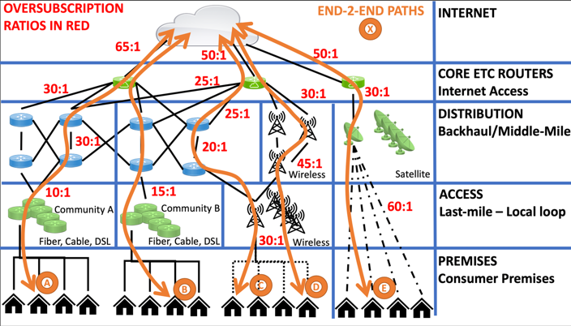
  - Finally, describe how the long-form applicant’s design will meet the peak period end-to-end performance requirements for the path from the consumer premises to the Internet. This requires that the applicant detail consumer path use case(s) that the long-form applicant will use to move traffic to and from the consumer premises to the Internet. This description should define the technical, planning and capacity parameters that a stream of packets would experience along this end-to-end path. For example, the diagram below shows five paths labelled A through E. This includes various oversubscription ratios, link media (wired, wireless, etc.), redundancy, and multi-homing characteristics. However, the diagram does not show the equipment types and other information that might be relevant to the long-form applicant’s network. The diagram below is merely representational for purposes of this document. We expect individual path use cases to describe the pathway: links (media, technology, data-rates, redundancy, etc.); frequencies, channels, antenna and wireless parameters; topology (mesh, ring, hierarchical) that also note redundant links or multi-homing, etc.; network devices (equipment type, redundancy, reliability); protocols; oversubscription ratios; and ETC owned vs leased infrastructure.

- Project Plan. The applicant will provide a project plan that describes a network build-out schedule that includes but is not restricted to plans for constructing last mile and middle mile facilities.

  - The build-out schedule should include when (month, quarter or projected date) and where (geographic description, county, city, town, CBG, census tract; note the state or higher level is not acceptable).

  - The build-out schedule should show the long-form applicant’s projected milestones on an annual basis, including achievement of the interim service milestones described in section 54.802(c) of the Commission’s rules and completion of the network for the number of locations determined by the CAM by the end of the sixth year of support.

  - The project plan and included schedule should incorporate detailed information showing how the long-form applicant plans to offer, to at least 95% of the required number of locations in each relevant state, voice and broadband service meeting the relevant performance requirements when the system is complete.

- Network Management and On-going Operations. The applicant’s detailed description should:

  - Describe the applicant’s plans for monitoring network usage/capacity, performance, congestion, and other parameters.

  - Describe how the applicant will maintain the performance and quality of the service for the duration of the 10-year support term.

  - Describe who will provide these services. Will the applicant: 1) use existing internal organizations, 2) use contracted management service providers, 3) create new internal organizations, or 4) engage new contractors?

  - Describe how the applicant will comply with Commission performance measures for speed and latency. The description should include whether the applicant plans to use the Measuring Broadband America (MBA) system, off-the-shelf testing mechanisms such as existing network management systems and network management tools, or provider-developed self-testing mechanisms.

- Network Diagram. The network diagram must be certified by a professional engineer and should:

  - Identify all wireline and wireless segments of the proposed networks. This should include applicable middle-mile/backhaul and interconnection network infrastructure. These are also commonly referred to as “links” between the nodes. These descriptions should indicate the media/link technology, data-rate/speed, and topology if point-to-point, ring, etc.

  - Uniquely identify (i) major network nodes including their manufacturer and model, as well as their functions, locations, and throughput/capacity; (ii) access nodes or gateways, including their technology, manufacturer and model, location, and throughput/capacity; and (iii) major inter-nodal links (not last mile), and their throughput/capacity.

  - Indicate how many locations/consumers will be offered service from each access node or from each gateway, and which performance tier or tiers will be supported at each access node.

  - Indicate what parts of the network will be new deployment and what parts will use existing network facilities.

  - Identify specialized nodes used in providing voice service, such as SIP servers, PSTN gateways or voice OTT providers.

  - Explain how nodes or gateways are connected to the Internet backbone and Public Switched Telephone Network. Show redundancy, dual- or multi-homing configurations.

- Terrestrial Fixed Wireless. A long-form applicant that proposes to use terrestrial fixed wireless technologies should:

  - Explain, with technical detail, how the proposed spectrum can meet or exceed the relevant performance requirements at peak usage periods. Clearly identify the licensed and unlicensed spectrum that will be used.

  - Provide the calculations used, for each performance tier and frequency band, to design the last mile link budgets in both the upload and download directions at the cell edge, using the technical specifications of the expected base station and customer premise equipment. Submit assumptions regarding fading statistics, cell edge probability of coverage, and cell loading for each relevant performance tier.

  - Provide coverage maps for the planned and/or existing networks that will be used to meet the Rural Digital Opportunity Fund public interest obligations, indicating where the upload and download speeds will meet or exceed the relevant performance tier speed(s). The coverage maps should be provided for each interim and final service milestone and should display the required service areas and target locations (or a representation thereof).

  - Provide detailed radio access network (RAN) infrastructure information used to generate the coverage maps for each unique cell including longitude, latitude, antenna height, antenna orientation, antenna down-tilt, antenna model, antenna system configuration, effective radiated power, operating spectrum amount, operating spectrum type, and operating radio technology.

  - Describe the underlying propagation model used to prepare the coverage maps and how the model incorporates the operating spectrum, antenna heights, distances, fading statistics, terrain resolution, and clutter resolution.

  - Describe the underlying cell site and generally, radio frequency (RF) access network capacity management and traffic engineering models or concepts. Also describe any adjunct carrier aggregation or spectrum sharing techniques and if the proposed system could accommodate these features, if needed.

  - Describe, for each relevant performance tier and latency combination, the base station equipment that the long-form applicant plans to use.

  - Describe the planned customer premise equipment configuration.

- Satellite Technologies. A long-form applicant that proposes to use primarily satellite technologies should:
  - Describe how many satellites that are in view simultaneously from any specific location will be required to meet the relevant Rural Digital Opportunity Fund public interest obligations.

  - Describe how many uplink and downlink gateway antenna beams will be required on each satellite, and the capacity of each beam in megabits per second. For each winning bid area/state to be served, provide both the uplink and downlink beams, provide the gateway call sign, beam ID, frequency bands used, and location (city/state).

  - Describe how many uplink and downlink user antenna beams will be required on each satellite, and the capacity of each beam in megabits per second.

  - Describe how the gateway capacity is connected to user beams on the satellite, in terms of beams and data capacity per beam.

  - Describe how much satellite capacity (in gigabits per second) the applicant plans to reserve, by winning bid area/state, to serve the locations required under applicant’s award and to achieve the required service milestones.

  - Describe whether the capacity on the uplink and downlink beams would be able to be reallocated once a satellite commences operation, if the subscription rate is less than 70% in one beam but more than 70% in another beam. If there are circumstances in which such reallocation would not be possible, please describe those circumstances and the states impacted.

Commission decisions adopting rules and policies for the Rural Digital Opportunity Fund and Auction 904, as well as detailed public notices outlining the procedures, terms, and conditions for the auction control and can be found on the Auction 904 website and through the FCC’s Electronic Document Management System (EDOCs) database.
Architectures include, for example, wireless licensed or unlicensed, fiber, coaxial cable, satellite, digital subscriber line, hybrids, etc. Protocols encompass a wide variety of use categories and standards organizations to include: routing, e.g., OSPF, IS-IS, iBGP, BGP, eBG; traffic engineering, e.g., MPLS, PBB, VPLS; Quality of Service, e.g., DSCP, DiffServ, RSVP, IntServ, ToS, 802.1Q; last-mile, e.g., DOCSIS, Active Ethernet, GPON/PON, VDSL, ADSL, LTE, WiMAX, 5G-NR, and 802.11 variants; voice services, e.g., TDM, SIP, H.323, VoLTE, H.248, MGCP, and RTP. Design includes the links/connectivity in the network, including link speeds, redundancy, load-balancing, fail-over, and associated protocols, topologies, and technologies. Technologies include traffic-engineering, QoS (Quality of Service), or both methods that aid in the performance of its network. Generally, methods of traffic engineering include, but are not limited to, MPLS, PBB, VPLS, SD-WAN. Methods of Quality of Service (QoS) include, but are not limited to, DSCP, DiffServ, RSVP, IntServ, ToS, and 802.1Q.
For example, describe its network topologies (the layout pattern of interconnections between node devices in a network). There are many different types of network topologies, including point-to-point, linear, daisy-chain, bus, tree, star, ring, dual-ring, mesh (partial & full), and hybrid. There are also technology-specific topologies such as FTTH, FTTN, HFC, PTP, PTMP, and ERPS.
This includes selected transient or Internet service provider names and IXP location names or at a minimum city and state location.
If the long-form applicant obtains these or other voice service functions as services from another provider or providers (for example, an over-the-top VoIP provider, or an incumbent or competitive local exchange carrier), the description should so indicate. Voice solutions are a collection of integrated sub-systems dependent on selected architecture and design implementation. These architectures can include items such as: SIP, H.323, and MGCP; internal trunking, e.g., SIP trunks; quality of service protocols and use; connectivity to the PSTN and other VoIP providers; associated internal traffic-engineering to support voice quality; and more. If the applicant is using a hosted or Managed Service Provider (MSP) for its voice solution it must provide and sufficiently describe its infrastructure support. Such network infrastructure support solutions may include Quality of Service (QoS), voice paths setup by traffic-engineering protocols, trunking, and other methods, e.g., when using a voice MSP (Managed Service Provider).
See Rural Digital Opportunity Fund Phase I Auction Scheduled for October 29, 2020; Notice and Filing Requirements and Other Procedures for Auction 904, AU Docket No. 20-34 et al., Public Notice, 35 FCC Rcd 6077, 6127-29, paras. 135-39 (2020) (Auction 904 Procedures Public Notice). (describing how an ETC must offer qualifying voice service using its own facilities, at least in part).
Capacity per user: busy hour offered load (BHOL) can also be used.
The oversubscriptions in this diagram example are not meant to be representative or recommendations for the actual subscription ratios that ETCs should use in their networks.
For wireless base stations and their pertinent backhaul, provide the planned number of subscribers, monthly target GB (Gigabytes) per subscriber and oversubscription ratio. Provide if and how a mix of speed tiers could be provided.
Network management systems are a mix of personnel, organizations, software, equipment, and processes. These resources are organized along generally accepted frameworks such as FCAP, ITIL or SIEM.
Widely used network level performance management techniques include traffic-engineering, Quality of Service, over-building/scalability, redundancy, load-balancing, equipment that easily allows upgrades and a variety of other techniques. Relevant information can include oversubscription ratios at all network levels, assumptions, specific calculations, and most importantly PEAK period impact. Lastly, the answer must provide and sufficiently describe the rules of thumb and effective corrective actions as requested for all three levels of the network (last-mile, middle-mile, and core/Internet-connections.
See generally Connect America Fund, Order, 33 FCC Rcd 6509 (WCB/WTB/OET 2018) (CAF Performance Measures Order). Further modifications were made to the performance measures requirements in subsequent reconsideration orders. See Connect America Fund, Order on Reconsideration, 34 FCC Rcd 8081 (WCB/WTB/OET 2019) (CAF Performance Measures First Reconsideration Order); Connect America Fund, Order on Reconsideration, 34 FCC Rcd 10109 (2019) (CAF Performance Measures Second Reconsideration Order) (describing the methodologies for the Commission’s performance measures).
Major nodes include, but are not necessarily restricted to, routers, SIP Proxies, soft switches, and databases, e.g., DNS services, used to route Internet communications and voice calls; and Points of Interconnection with the Public Switched Telephone Network and the Internet core.
A long-form applicant should provide a reasonably descriptive label for where the node is located. For example, identify the city or town, village or suburb where the node is located. Street address and latitude/longitude are not required but can also be used.
Capacity should be measured in Gigabits per second for routers, calls per hour for SIP proxies and soft switches, queries per minute for databases, and appropriate units for other nodes.
An access node connects a customer’s connection to the core of the network. Access nodes include wireless base stations, digital subscriber line access modules, cable modem termination systems, and optical line terminations, among others. Access nodes are sometimes referred to as aggregation nodes. When we reference gateways, we are referring to the gateway earth stations used by satellite providers.
Include links that connect access nodes to the network core, among other major inter-nodal links. Each inter-nodal link should be identified by specifying the nodes at the ends of the link.
The justification should clearly define all relevant assumptions including, but not limited to, oversubscription ratio, number of locations, spectrum efficiency, bandwidth, peak periods required user data rate, and peak periods network loading.
This should include a description of all design assumptions, including, but not limited to, coverage reliability, fade margins, required frame error rate, required signal-to-noise ratio, and modulation/coding scheme associated with frame error rate and signal to noise ratio.
The term cell edge is commonly used to describe the edge of the base station coverage area beyond which performance goals cannot be achieved. A support recipient cannot report a location as served in satisfaction of its Auction 904 deployment obligations until it is capable of providing a voice and broadband service meeting the relevant performance tier and latency public interest obligations to that location within 10 business days upon request. Auction 904 Procedures Public Notice, 35 FCC Rcd at 6084-85, para. 17.
Typically, a coverage plot must demonstrate that service to a proposed location will meet or exceed the prerequisite broadband speed and voice service requirements. Unlike legacy technologies, current and future generation technologies typically use speed for such coverage plots.
Coverage map guidelines are provided in the wireless coverage maps data specification posted on the Auction 904 website under the “Education tab.”
For example, transmit diversity, multiple-in-multiple-out (MIMO) and beam switching.
A long-form applicant should provide vendor references and publicly available publications for the utilized model, digital elevation, and clutter data.
In order to fulfill this requirement, the long-form applicant could describe the concept and specific best practices the applicant currently follows or intends to implement.
Such a description should include technology, speed, number of sectors, average number of subscribing locations per sector, frequency band, channel bandwidth, frequency reuse, antenna gain, diversity configuration, estimated losses, estimated height above ground, base station coordinate in NAD 83, and any other relevant information. A long-form applicant should also include vendor specification data sheets or other supporting documents.
Such a description should include technology, applicable frequency band, speed options, antenna gain, diversity scheme and modem specifications. A long-form applicant should also include vendor specification data sheets or other supporting documents.
This does not include long-form applicants that intend to use satellite technologies primarily for backhaul.

