42 MEETING OF PERMANENT  CONSULTATIVE COMMITTEE II:  RADIOCOMMUNICATIONS  August 28 to September 01, 2023  Ottawa, Canada |  | OEA/Ser.L/XVII.4.2.42  CCP.II-RADIO /doc. 5939/23  13 August 2023  Original: English
 | PROPOSALS FOR THE WORK OF THE CONFERENCE AGENDA ITEM 9.2 - No. 21.5
 | (Item on the Agenda: 3.1 (SGT-1))
 | (Document submitted by the delegation of the United States of America)
Impact on the sector:

This document supports the work of CITEL’s PCC.II Working Group for WRC under 3.1 (SGT-1) of the agenda.

Executive Summary:
Under agenda item 9.2, the United States makes the proposals below on the following sections of the BR Director’s Report:
- RR No. 21.5

Background:

Based on a CITEL proposal to WRC-19 under agenda item 1.13, WRC-19 identified the 24.25 – 27.5 GHz band for International Mobile Telecommunications (IMT) on a global basis (see No. 5.532AB) with regulatory provisions to ensure the protection of incumbent services contained in Resolution 242 (WRC-19) and Resolution 750 (WRC-19). Based on the results of sharing studies between IMT using an array of active elements and satellite services conducted in Task Group 5/1 that indicated a significant I/N margin to protect ISS and FSS, WRC-19 decided it was not necessary to make any modifications to Article 21, including Table 21-2.
However, in the discussions on the RCC Regional Commonwealth in the Field of Communications proposal in WRC-19 Document 12 (Add.13) regarding the inclusion of a definition for total radiated power (TRP) in Article 1, as well as the amendment of No. 21.5 to address the stations with an active antenna system (AAS), the Ad-Hoc Group of the Plenary on agenda item 1.13 provided a view that was included in the Minutes of the Plenary. The following text set out in the Annex to WRC-19 Document 550 was approved and included in the minutes of the meeting as a decision of the conference (WRC-19 Document 573):

Verification of No. 21.5 for the notification of IMT stations operating in the frequency band 24.45-27.5 GHz which use an antenna
that consists of an array of active elements
ITU-R is invited to study, as a matter of urgency, the applicability of the limit specified in No. 21.5 of the Radio Regulations (RR) to IMT stations that use an antenna that consists of an array of active elements, with a view to recommend ways for its possible replacement or revision for such stations, as well as any necessary updates to RR Table 21-2 related to terrestrial and space services sharing frequency bands.
Furthermore, the ITU-R is invited to study, as a matter of urgency, verification of RR No. 21.5 regarding the notification of IMT stations that use an antenna that consists of an array of active elements, as appropriate.”

The process of notification of IMT stations the ITU-R utilizes a set of parameters listed for reference in Form T-12 including frequency assignment, antenna gain, conducted power, e.i.r.p., among others. RR No. 21.5 limits the power delivered by “a transmitter to the antenna of a station”. It regulates output power of each and every transmitter of any given station, not the output power of the entire station, which is the limit stipulated in No. 21.3. The limit of RR. No. 21.5 is independent of the number of transmitters and number of antennas at a station as per the definition of a station in RR. No. 1.61. For the purpose of notification of IMT AAS stations, item identifier 8AA as defined in Form T-12 corresponds to the conducted power of a single transmitter irrespective of the number of antennas per transmitter. In order to aid administrations in the submission and notification of frequency assignments and allotments to stations in the fixed, mobile and other terrestrial services, the ITU has created Guidelines to describe the process. According to FXM Guidelines, “In fact, there is no limit concerning the number of "antennas" for a notice, and no limit concerning the number of receiving sites per antenna.” Also, “there is no limit concerning the number of transmitting "antennas" for a notice.” It should be noted that the precise parameters for the assignment, the antenna, and the receiving site vary according to the notice type.
Figure 1
General structure of an example T12 notice file
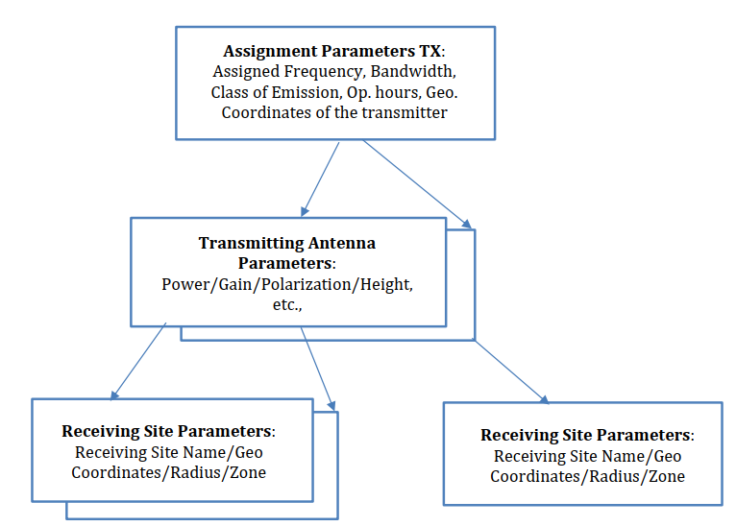
The process of notification of IMT stations includes declaration of several station parameters including transmitter conducted output power (8AA). The guidelines present sufficient flexibility to accommodate various types of stations with different types of architecture and parameters. For instance, stations operating on the same frequency assignment could be notified separately when one or more other parameters vary. Therefore, RR No. 21.5 simply applies to the entry for the conducted power of each transmitter output power irrespective of the frequency assignment.
Thus, the current guidelines as presented by the ITU cover the case of an IMT station using an antenna using an array of active elements in the 26 GHz band and no changes are needed to the Radio Regulations.
Other alternative methods that have been studied in the ITU, for example adopting a new, Total Radiated Power (TRP) limit on the entire IMT station utilizing AAS as opposed to the current language of RR No. 21.5 which applies the limit to the conducted output power of one transmitter. Such a deviation from the letter of the Radio Regulations would discourage the use of larger arrays utilizing higher gain and significantly impact performance of existing and future IMT deployments leading to additional cost and complexity implications for the network operator and consequently for the subscribers, while not bringing additional protection for space stations. As shown in the studies performed at the ITU, it is observed that the IMT AAS base station emissions towards satellites are not governed by the TRP of the station, but by the conducted power per individual transmitter of the station. This is in accordance with the letter of RR No. 21.5, whose limit applies to “The power delivered by a transmitter to the antenna of a station”. It should be noted that the protection of space receivers is ensured by RR No. 21.3, which sets the radiated power limit of the entire terrestrial station:
“The maximum equivalent isotropically radiated power (e.i.r.p.) of a station in the fixed or mobile service shall not exceed +55 dBW.”

Further, in the Radio Regulations, no indications are given of a “reference bandwidth” on which RR Nos. 21.3 and 21.5 should be applicable or notified on. The limits are given in terms of power and not Power Spectral Density (PSD). Therefore, they apply to any value given in the notification process declared under item 7AB as “necessary bandwidth”. With historical trends towards use of larger bandwidth by terrestrial systems, not specifying a bandwidth has led to a decrease in PSD towards other systems over the years, thus reducing the overall likelihood of harmful interference to other services. There is therefore no need to specify a fixed bandwidth for the limit in RR No. 21.5 or RR No. 21.3.

Proposal:

NOC USA/9.2/1
ARTICLES

Reasons: No changes to the Radio Regulations are necessary to address the verification of No. 21.5 for the notification of IMT stations operating within the 24.45-27.5 GHz frequency range which use an antenna that consists of an array of active elements.

ARTICLE 21
Terrestrial and space services sharing frequency bands above 1 GHz
Section II − Power limits for terrestrial stations
NOC USA/9.2/2
21.5 3) The power delivered by a transmitter to the antenna of a station in the fixed or mobile services shall not exceed +13 dBW in frequency bands between 1 GHz and 10 GHz, or +10 dBW in frequency bands above 10 GHz, except as cited in No. 21.5A. (WRC-2000)
Reasons: Current BR guidelines for notification of terrestrial stations apply. Regarding the notification of IMT stations which use an antenna consisting of an array of active elements, , Administrations should provide the radiated power (Item identifier 8B of RR Appendix 4) in the application of RR No. 21.3 for the band 24.45-27.5 GHz, which is shown as mandatory data item in RR Appendix 4, as well as the conducted output power delivered by each and every transmitter to the antenna of the station (Item identifier 8AA of RR Appendix 4) irrespective of the number of elements comprising the antenna fed by each transmitter.

NOC USA/9.2/3
TABLE 21-2 (Rev.WRC-19)
Frequency band | Service | Limit as specified  in Nos.
1 427-1 429 MHz  1 610-1 645.5 MHz (No. 5.359)  1 646.5-1 660 MHz (No. 5.359)  1 980-2 010 MHz  2 010-2 025 MHz (Region 2)  2 025-2 110 MHz  2 200-2 290 MHz  2 655-2 670 MHz 5 (Regions 2 and 3)  2 670-2 690 MHz 5 (Regions 2 and 3)  5 670-5 725 MHz (Nos. 5.453 and 5.455)  5 725-5 755 MHz 5 (Region 1 countries listed in Nos. 5.453 and 5.455)  5 755-5 850 MHz 5 (Region 1 countries listed in Nos. 5.453 and 5.455)  5 850-7 075 MHz  7 145-7 235 MHz*  7 900-8 400 MHz | Fixed-satellite  Meteorological-satellite  Space research  Space operation  Earth exploration-satellite  Mobile-satellite | 21.2, 21.3,  21.4 and 21.5
10.7-11.7 GHz 5 (Region 1)  12.5-12.75 GHz 5 (Nos. 5.494 and 5.496)  12.7-12.75 GHz 5 (Region 2)  12.75-13.25 GHz  13.75-14 GHz (Nos. 5.499 and 5.500)  14.0-14.25 GHz (No. 5.505)  14.25-14.3 GHz (Nos. 5.505 and 5.508)  14.3-14.4 GHz 5 (Regions 1 and 3)  14.4-14.5 GHz  14.5-14.8 GHz  51.4-52.4 GHz | Fixed-satellite | 21.2, 21.3 and 21.5
17.7-18.4 GHz  18.6-18.8 GHz  19.3-19.7 GHz  22.55-23.55 GHz  24.45-24.75 GHz (Regions 1 and 3)  24.75-25.25 GHz (Region 3)  25.25-29.5 GHz | Fixed-satellite  Earth exploration-satellite  Space research  Inter-satellite | 21.2, 21.3, 21.5  and 21.5A
Reasons: No modifications are necessary.
NOC USA/9.2/4
APPENDICES
Reasons: No modifications are necessary.

_____________

