44 MEETING OF PERMANENT  CONSULTATIVE COMMITTEE II:  RADIOCOMMUNICATIONS  September 23 to 27, 2024  Merida, Mexico |  |  | CITEL/GT/CMR-27/doc. /24  August 30, 2024  Original: English
 |  | Preliminary view for wrc-27 agenda item 1.16
 |  | (Item on the Agenda: 3.1)
 |  | (Document submitted by the Delegation of the United States)

SGT#: 3

Coordinator:

Vice-Coordinador:

Agenda Item Rapporteur:

Agenda Item Vice-Rapporteur:

UNITED STATES OF AMERICA

DRAFT PRELIMINARY VIEWS FOR WRC-27

Agenda Item 1.16: to consider studies on the technical and regulatory provisions necessary to protect radio astronomy operating in specific Radio Quiet Zones and, in frequency bands allocated to the radio astro​​nomy service on a primary basis globally, from aggregate radio-frequency interference caused by non-geostationary-satellite orbit systems, in accordance with Resolution 681 (WRC-23);

BACKGROUND:
In accordance with Resolution 681 (WRC-23), WRC-27 agenda item 1.16 invites studies, including (1) impacts to radio astronomy service (RAS) systems from interference from unwanted emissions from non-GSO satellite systems operating in the adjacent bands to a set of RAS primary frequency bands (see Table 1) and (2) studies on the possible recognition of the two specific RQZs listed below, and the impact of non-GSO systems operation on these two sites:

– the Square Kilometre Array Observatory in South Africa;
– the Atacama Large Millimeter/submillimeter Array (ALMA) in Chile

Table 1
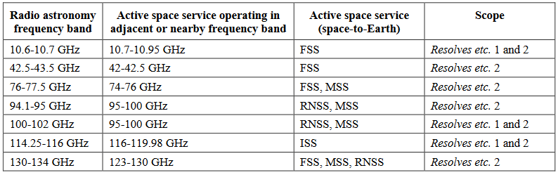

The Resolution does not explain what is meant by recognition and does not address the fact that many frequency bands used at these two sites are not allocated in Article 5 of the Radio Regulations to the radio astronomy service.

U.S. VIEW:
The United States supports conducting the sharing and compatibility studies called for in Resolution 681 (WRC-23), resolves 1 to 2 and limited to the frequency bands in Table 1 of Resolution 681 (WRC-23) where the Radio Astronomy Service (RAS) is allocated on a primary basis.

With respect to the other resolves, including the RQZ studies for the two identified sites, the United States is of the view that studies should focus on providing tools that help manage the coexistence and provide recommended best practices without the need for changes to the Radio Regulations and take into account the allocation status of the services in each frequency band in which observations are conducted. It is important not to take actions that could impose undue constraints on non-GSO operations critical for global communications infrastructure, while recognizing and supporting the key importance of scientific endeavors. Accordingly, the United States does not support any changes to the Radio Regulation as a result of the activities undertaken with respect to Resolution 681 (WRC-23) resolves 3 to 6.

____________________

