ACP 20 Million Enrollment Milestone
Last Updated 8.15.23
Post Copy | Graphic
More than 20 million eligible households are now receiving affordable high-speed internet service thanks to the Affordable Connectivity Program.  Sign up, connect, and save at GetInternet.gov. | 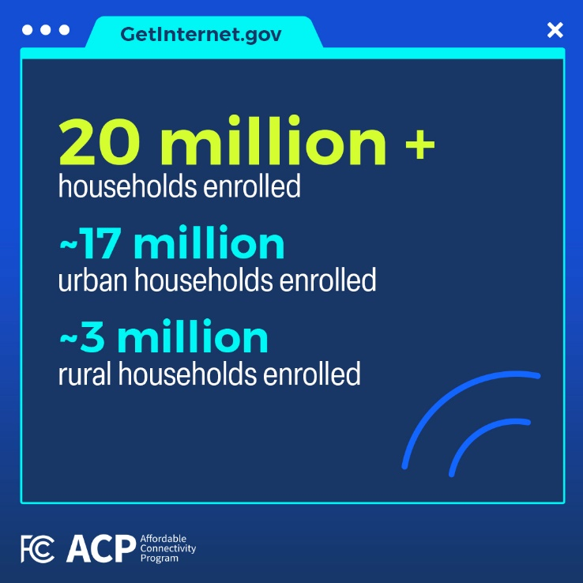
The Affordable Connectivity Program has helped more than 20 million eligible households across the country get online and stay online. Learn more at GetInternet.gov.
High-speed internet helps you connect for work, school, health care, and more. Thanks to the Affordable Connectivity Program, more than 20 million eligible households now have access to affordable high-speed internet service.  Want to see if you’re eligible? Visit GetInternet.gov. | 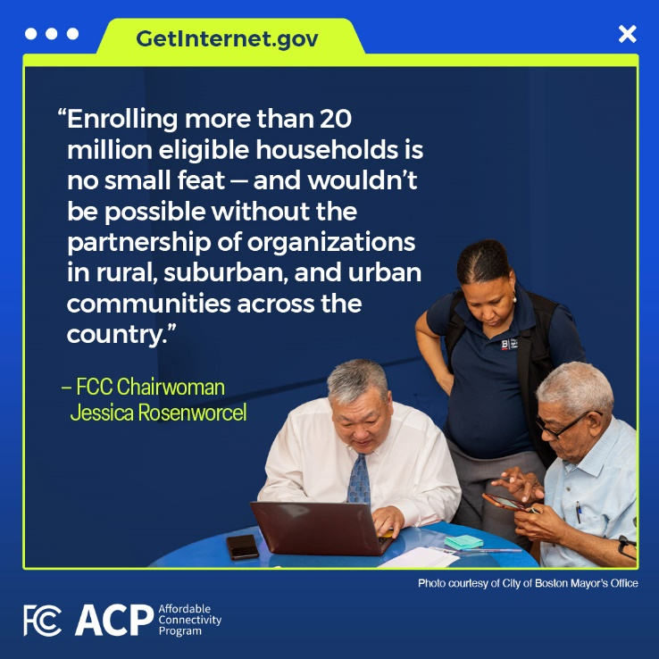
The Affordable Connectivity Program is now helping more than 20 million eligible households connect to affordable high-speed internet service, so they can access resources for work, school, health care and more.
Visit GetInternet.gov to learn more.
The Affordable Connectivity Program is helping eligible households in every state and U.S. territory connect to affordable internet service.  Could you be eligible for internet savings? Sign up, connect and save at GetInternet.gov. | 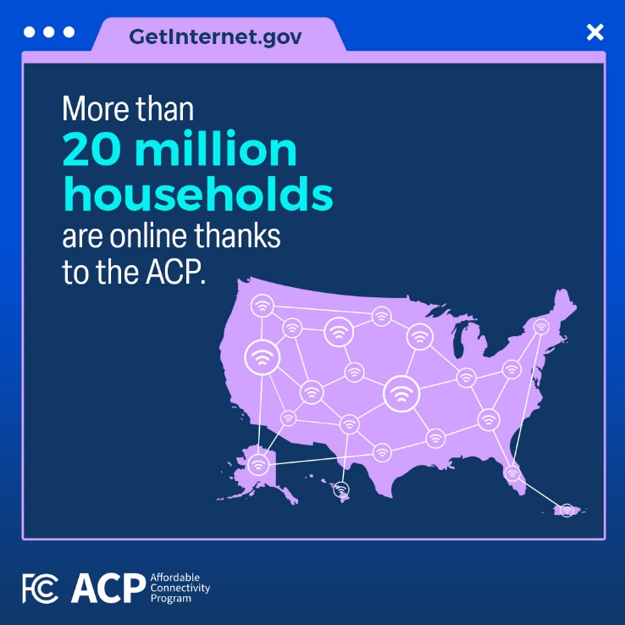
#DYK the Affordable Connectivity Program has helped eligible households in every state and U.S. territory connect to internet service?
Learn more about the ACP at GetInternet.gov.

