Partners can tweak these suggested social media posts to fit their voice.

Sample Tweets

Note: ***indicates that the proceeding tweet will be tweeted in a series.

- Recently, Congress created @FCC’s Affordable Connectivity Program, a $14 billion program, that replaced the Emergency Broadband Benefit Program. This investment in #broadband will help people afford the internet connections they need to survive. Details: FCC.gov/ACP.

- The @FCC’s Affordable Connectivity Program has replaced the Emergency Broadband Benefit. This program provides a discount of up to $30 per month toward internet for eligible households and up to $75 per month for homes on qualifying Tribal lands. Details: FCC.gov/ACP.

- The @FCC’s Affordable Connectivity Program provides eligible households with a discount on #broadband service and connected devices. Learn if you qualify for the program and how to apply here: AffordableConnectivity.gov #BroadbandForAll #FCCGov
***Eligible households can also receive a one-time discount of up to $100 for a laptop, desktop computer, or tablet purchased through a participating provider.

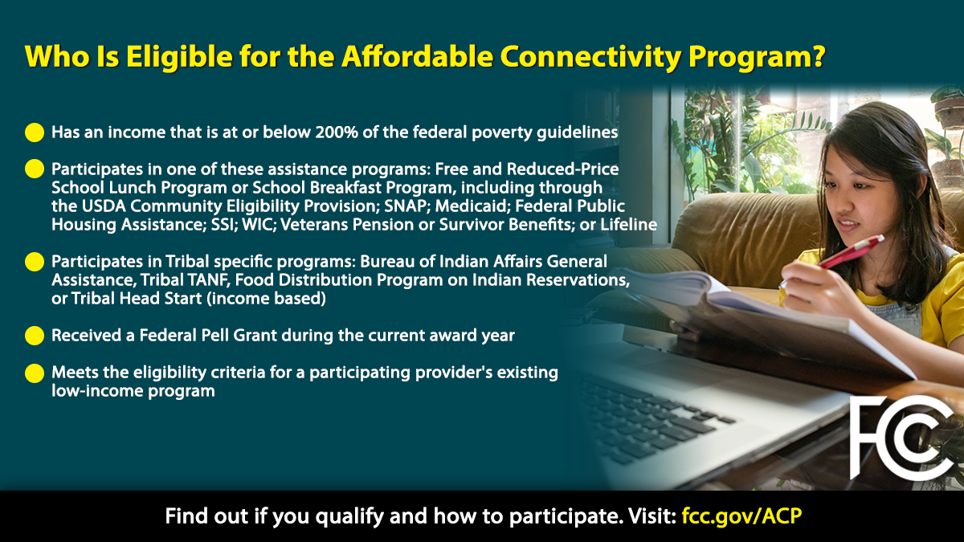

- Thanks to the Bipartisan Infrastructure Law, more than 11.5 million people who previously couldn’t get online or struggled to pay for #broadband, a modern-day necessity, are now connected through the Affordable Connectivity Program. www.fcc.gov/ACP
***This $14.2 billion successor program to the Emergency Broadband Benefit provides qualified low-income households with a discount of up to $30 per month toward internet service & up to $75 per month for eligible households on Tribal lands. #BroadbandForAll

- The $14.2 billion Affordable Connectivity Program has now served more than 11.5 million households. Here are 10 ways you can help the @FCC spread the word: https://go.usa.gov/xtMBf. #FCCGov #BroadbandForAll

- Review: 10 ways you can help the @FCC spread the word about the Affordable Connectivity Program that helps people get the internet connections they need for work, school, health care, and much more: https://go.usa.gov/xtMBf. #FCCGov #BroadbandForAll

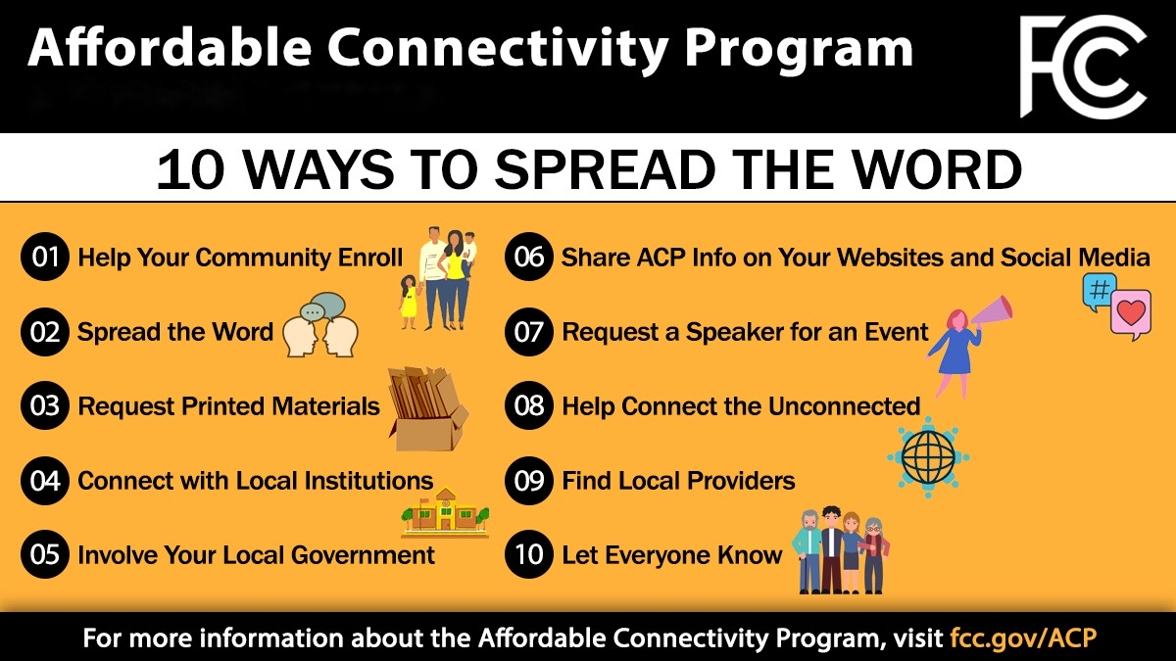

Here are the steps to enrolling in the Affordable Connectivity Program:
1. Go to AffordableConnectivity.gov to submit an application or print out a mail-in application.
2. Contact your preferred participating provider to select an eligible plan & have the discount applied to your bill.
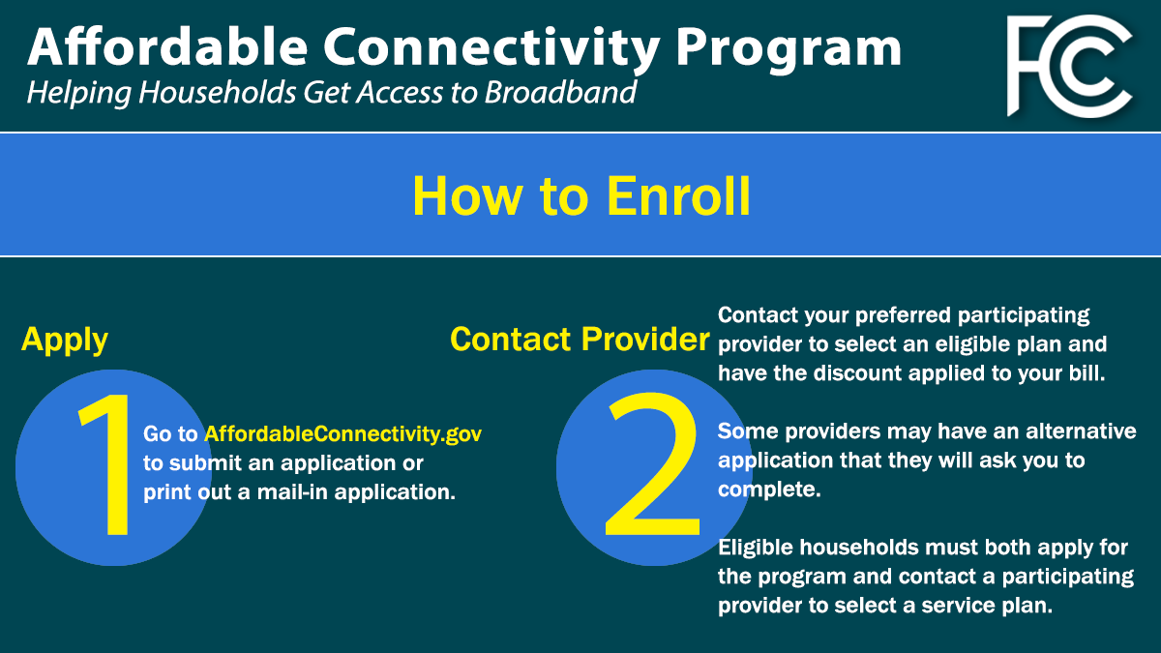

- Learn who’s eligible for the @FCC’s Affordable Connectivity Program by visiting: fcc.gov/ACP. #BroadbandForAll

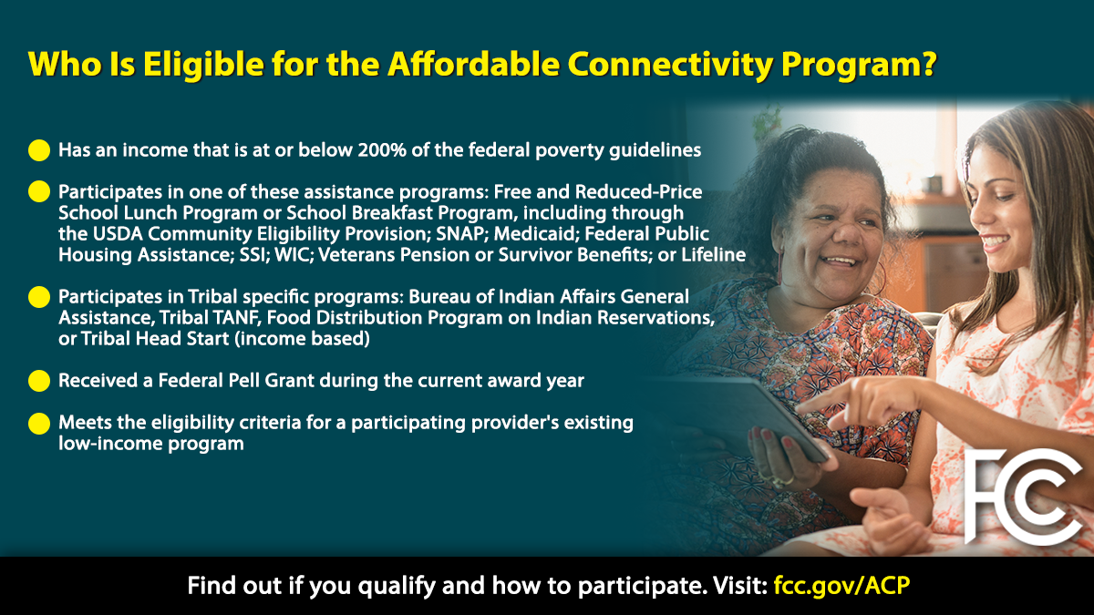

Sample Facebook Posts

- Recently, Congress created the FCC’s Affordable Connectivity Program, a $14 billion program that replaced the Emergency Broadband Benefit Program. This investment in broadband affordability will help people get the internet connections they need for work, school, health care and much more. Learn more about the program here: FCC.gov/ACP. #BroadbandForAll
- The Affordable Connectivity Program provides eligible households with a discount on broadband service and connected devices. This program provides a discount of up to $30 per month toward the internet for eligible households and up to $75 per month for homes on qualifying Tribal lands. Find out if you're eligible for the program and how to apply here: AffordableConnectivity.gov #BroadbandForAll #FCCGov
- The $14.2 billion Affordable Connectivity Program has now served more than 11.5 million households. Here are 10 ways you can help the FCC spread the word: https://go.usa.gov/xtMBf. #FCCGov #BroadbandForAll
- Review: 10 ways you can help the Federal Communications Commission spread the word about the Affordable Connectivity Program that helps people get the internet connections they need for work, school, health care, and much more: https://go.usa.gov/xtMBf. #FCCGov #BroadbandForAll

